

SIET TASK MANAGEMENT SYSTEM

PROJECT REPORT

Submitted by

VIBIN RICHARD D (714023205159)
THIKANTHRA G (714023205154)
SRINIVASAN D (714023205142)

In partial fulfilment for the award of the degree of

BACHELOR OF TECHNOLOGY
In
INFORMATION TECHONOLOGY

SRI SHAKTHI
INSTITUTE OF ENGINEERING AND TECHNOLOGY

An Autonomous Institution, Accredited by NAAC with “A” Grade

ANNA UNIVERSITY: CHENNAI 60002
FEBRUARY 2024

BONAFIDE CERTIFICATE

Certified that this report titled “SIET task management system” is the bonfied work of “Vibin Richard D (714023205159), Thikanthra G (714023205154), Srinivasan D (714023205142)”, who carried out the project work under our supervision.

Project Guide Project Co-Ordinator
Dr S Prakash, Dr M Deepa,
Professor, Associate Professor,
Dept. of Information Dept. of Information Technology. Technology.

Head of the Department
Dr S Prakash,
Professor,
Dept. of Information Technology.

Submitted for the project work Viva Voce Examination held on………………….…..

Internal Examiner External Examiner

ACKNOWLEDGEMENT
We extend our heartfelt gratitude to our honourable Chairman, Dr. S. Thangavelu for providing a wonderful platform to educate our minds, inculcate ideas and implement the technological changes in the real-world environment.
Our sincere thanks to our enthusiastic Secretary, Mr. T. Dheepan for making us realize the significance of bringing out the thesis of our project into practical implementation such that it can be an apt solution for any existing problems.
Deepest thanks to our dynamic Joint Secretary, Mr. T. Sheelan for monitoring the infrastructure and for providing the work atmosphere to implement the project and providing an excellent and maintaining the decorum and discipline of the students.
We are tremendously thankful to our beloved Principal, Dr. Elangovan for his incredible support to make us follow ethics and morality in our life and also for allocating sufficient time and resources.
A big salute to our vibrant Head of the Department, Dr. S. Prakash for imbibing scope of the project and systematic procedure in execution. We express our genuine thanks for encouraging us throughout the project period to complete it successfully.
Our great thanks to the Project mentor, Dr .S. Prakash for her ever lasting contribution in making the project a smooth journey and also for her valuable guidance and for making us realize our potential and be successful.
Our great thanks to the Project Co-Ordinator, Dr. M. Deepa for her ever lasting contribution in making the final year project phase a smooth journey and also for her valuable guidance and for making us realize our potential and be successful. We also thanks for her kind help and Cooperation throughout the research period to make us a grant successful completion of project.

VIBIN RICHARD D
THIKANTHRA G
SRINIVASAN D

ABSTRACT

Managing tasks and activities within a college campus setting presents unique challenges due to the diverse range of activities, stakeholders, and deadlines involved. To address this, the SIET Task Management System (SIET) offers a robust solution tailored to the specific needs of campus environments. Key functionalities of SIET include event scheduling, resource allocation, real-time updates, communication tools, and analytics capabilities. These features facilitate seamless coordination and collaboration among campus stakeholders, fostering a culture of efficiency and accountability.

By streamlining task management processes and promoting transparent communication, SIET empowers college communities to achieve their goals effectively and efficiently. Its implementation has the potential to revolutionize campus operations, enhance student engagement, and improve overall organizational effectiveness. In summary, SIET represents a transformative tool for enhancing productivity and collaboration within college campuses. By harnessing the power of technology to streamline task management, SIET enables colleges to adapt to the evolving needs of their communities and foster a culture of excellence and innovation.

TABLE OF CONTENTS
CHAPTER NO TITLE PAGE NO
ABSTRACT ii
LIST OF FIGURES vi
LIST OF ABBREVIATIONS vii
1 INTRODUCTION 1
1.1 Introduction to HTML & CSS 1
1.2 Introduction to JS 2
1.3 Introduction to SIET Task Management 4
2 LITERATURE REVIEW 5
3 EXISTING METHOD 8
3.1 User Authentication 8
3.2 User Authorization 8
3.3 Feedback and Surveys 9
3.4 Mobile accessibility 9
4 PROPOSED METHOD 10
4.1 Task Management Systems 10
4.2 HTML As A Department Language 10
4.3 Web Application Security 10
4.4 User Interface (UI) Design 10
4.5 User And Admin Roles 11
4.6 Dashboard Design 11
4.7 Learning Resources For HTML 11
And Web Development
4.7 Flowchart 12
5 SOFTWARE DESCRIPTION 13
5.1 HTML 13
5.2 CSS (CASCADING STYLE SHEETS) 13
5.3 JS (JAVA SCRIPT) 14
6 SOURCE CODE 16
6.1 HTML Code 16-36
7 RESULT AND ANALYSIS 37
7.1 Front Page 37
7.2 Login Page 38
7.3 User Page 39
8 CONCLUSION AND FUTURE SCOPE 40
8.1 Conclusion 40
8.2 Future Scope 40
8.2.1 Enhanced Reporting And Analytics 41
8.2.2 Integration With E-Commerce Platform 41
8.2.3 Mobile Application Development 41
8.2.4 Intelligent Inventory Management 41
8.2.5 Enhanced Security Features 41
9 REFERENCES 42

LIST OF FIGURES

FIGURE NO FIGURE TITLE PAGE NO
  - IMPLEMENTATION OF 12
SIET TASK MANAGEMENT
  - FRONT PAGE OF TMS 37
  - LOGIN PAGE OF TMS 38
  - MAIN PAGE OF TMS 39

LIST OF ABBREVIATIONS

HTML Hypertext Markup Language
CSS Cascadding Style Sheet
JS Java Script

CHAPTER 1
INTRODUCTION

1.1 INTRODUCTION TO HTML &CSS
HTML, or Hypertext Markup Language, is the standard markup language used to create and design web pages. It provides a basic structure for web content by using a set of tags that define elements such as headings, paragraphs, links, images, and more. HTML allows web browsers to interpret and display content in a structured manner, forming the backbone of every web page on the internet. As a simple and essential language, HTML is often combined with other technologies like CSS (Cascading Style Sheets) and JavaScript to create visually appealing and interactive websites. It serves as the foundation for building web pages and is crucial for anyone involved in web development.

CSS
CSS, or Cascading Style Sheets, is a styling language used in web development to enhance the presentation and appearance of HTML documents. It provides a set of rules that define how elements on a webpage should be displayed, allowing developers to control layout, typography, colors, and other visual aspects.CSS works in tandem with HTML, allowing developers to separate the structure (HTML) from the style (CSS) of a web page. By applying CSS rules to HTML elements, designers can achieve consistent and aesthetically pleasing layouts across different devices and screen sizes.

1.2 INTRODUCTION TO JS
JavaScript, often abbreviated as JS, was created by Brendan Eich in 1995 while he was working at Netscape Communications. Originally developed as a lightweight scripting language to add interactivity to web pages, it has since evolved into a powerful programming language widely used for both front-end and back-end development.
Here are some key features and concepts of JavaScript:
1. *Syntax*: JavaScript syntax is similar to that of C programming language. It uses curly braces for blocks of code and semicolons to terminate statements.
2. *Dynamic Typing*: JavaScript is dynamically typed, meaning you don't have to declare the data type of a variable explicitly. Variables can hold values of any data type.
3. *Functions as First-Class Citizens*: Functions in JavaScript are treated as first-class citizens, which means they can be assigned to variables, passed as arguments to other functions, and returned from other functions.
4. *Event-Driven Programming*: JavaScript is often used for event-driven programming, where actions on a web page (like button clicks or mouse movements) trigger JavaScript code to execute.
5. *DOM Manipulation*: JavaScript is commonly used to manipulate the Document Object Model (DOM) of a web page, allowing developers to dynamically change the content, structure, and style of a page in response to user actions.
6. *Asynchronous Programming*: JavaScript supports asynchronous programming through mechanisms like callbacks, promises, and async/await. This allows non-blocking code execution, essential for handling tasks such as fetching data from servers without freezing the user interface.
7. *Object-Oriented Programming (OOP)*: Although JavaScript is not a purely object-oriented language, it supports object-oriented programming concepts such as objects, classes (introduced in ES6), inheritance, encapsulation, and polymorphism.
8. *Frameworks and Libraries*: JavaScript has a vast ecosystem of frameworks and libraries that simplify and streamline development tasks. Some popular front-end frameworks include React.js, Angular, and Vue.js, while Node.js is a popular back-end framework.

1.3 INTRODUCTION TO SIET TASK MANAGEMENT

INTRODUCTION:

Effective SIET task management is the cornerstone of productivity and success in any organization, be it a small business, a large corporation, or an academic institution. A proper SIET Task Management System (SIET TMS) serves as the backbone of efficient operations, enabling teams to organize, prioritize, and execute tasks systematically. In today's fast-pace and interconnected world, where deadlines loom large and resources are limited, the need for a robust SIET TMS has never been greater. A proper SIET TMS goes beyond simple to-do lists and spreadsheets, offering a comprehensive platform that centralizes task-related information, facilitates collaboration, and provides insights for informed decision-making. By harnessing the power of technology, a SIET TMS streamlines workflows, minimizes errors, and fosters accountability among team members. This introduction sets the stage for exploring the key components and benefits of a proper SIET Task Management System, emphasizing its critical role in driving productivity, fostering teamwork, and achieving organizational goals. Whether in the realm of business, academia, or personal projects, implementing a SIET TMS can transform chaos into order and pave the way for sustainable success.

CHAPTER 2
LITERATURE REVIEW
2.1 Kasmawahida Ab Wahab, School of Computing & Analytics, Faculty of Science ,Engineering & Agrotechnology, University College of Yayasan Pahang, Taman Gelora Campus, 25050 Kuantan, Pahang, Malaysia
Task management systems are usually used by the project development teams to track their tasks from beginning to end, delegate subtasks to teammates, and set deadlines to make sure projects get done on time. It helps individuals to work more productively and efficiently. The same concept can be applied to students who have to perform group assignments but are located remotely from each other due to the closure of educational institutions because of the Covid19 pandemic. It is difficult for a student to divide group tasks since they only meet each other virtually through online classes with limited time. The objective of this project is to produce a web-based student task management system that can help UCYP students in managing their assignments and (to better manage the tasks assign) so they will not pass the deadline. The system has task tracking and recommendation features that help the student to manage their tasks easier and can decide the most important or critical task to do first. Student Task Management System implementing the Agile methodology in system development using JavaScript frameworks for both frontend and backend. The front-end is developed using Next.js and TypeScript while the back-end uses Node.js and GraphQL. The back-end itself will connect to the MongoDB database stored in the cloud using the MongoDB Atlas. This system implements authentication using the help of Firebase authentication which makes it easy for users to log in using their Google or Facebook accounts. The Web-based Student Task Management System was able to solve the problem of managing students’ tasks and making them become more productive and efficient in their studies.

2.2 Online Task Management System (OTMS), GRISHMA HEDAOO1, PRIYANKA THOKE2, RAKSHA TABHANE3, SHUBHAM MESHRAM4 ,SWAPNILKUMBHALKAR5, PROF. MUKESH BARAPATRE , S. B. Jain Institute of Technology, Management and Research, Nagpur, India
The Online Task Management System is designed from day to day working of department of a college. The project provides online platform to accomplish day to day department level task and provide information of the task to specified user. Admin can assign task, give notification and adds different users in this project. Important benefit of this proposed system is that the user-friendly design helps the admin and user to interact and accomplish various types of tasks online with ease. The Online Task Management System involves identifying, acquiring, allocating and tracking all the resources. Admin maintains a database system and is responsible for the performance of the system. Admin have authority to control the entire system. User have no authentication to see admin task. The purpose for developing this project is to generate a platform where admin can do all types of operations like view, insert, edit, events, delete and tracking operations. Admin user is a privileged user who can add/modify a task.

2.3 Author={Bellotti, Victoria and Dalal, Brinda and Good, Nathaniel and Flynn, Peter and Bobrow, Daniel and Ducheneaut , Nicolas},year = {2004},month = {04},pages = {735-742},title = {What a to-do: studies of task management towards the design of a personal task list manager},volume={24–29},journal = {Proceedings of CHI, Vienna, Austria}
This paper reports on the results of studies of task management to support the design of a task list manager. We examined the media used to record and organize to-dos and tracked how tasks are completed over time. Our work shows that, contrary to popular wisdom, people are not poor at prioritizing. Rather, they have well-honed strategies for tackling particular task management challenges. By illustrating what factors influence task completion and how representations function to support task management, we hope to provide a strong foundation for design of a personal to-do list manager. We also present some preliminary efforts in this direction.

CHAPTER 3
EXISTING METHOD

A Task Management System tailored to college environments, you can consider incorporating various modules to address the specific needs and workflows within a college setting.

3.1 User Authentication
User authentication is a critical component of any task management system, ensuring the security and integrity of user data and system functionality. This paper presents an overview of user authentication mechanisms employed in task management systems, focusing on key aspects such as username/password authentication, encryption techniques for storing passwords securely, session management, token-based authentication, two-factor authentication (2FA), role-based access control (RBAC), and audit trails.

3.2 User Authorization
User authorization is a fundamental aspect of task management systems, ensuring that users have appropriate access to system functionalities based on their roles and permissions. This paper provides an overview of user authorization mechanisms in task management systems, highlighting key elements such as role-based access control (RBAC), permissions management, access levels, and granular control over user actions.

3.3 Feedback and Surveys
User feedback mechanisms enable users to provide comments, suggestions, and criticisms directly within the task management system. These feedback channels can take various forms, including in-app feedback forms, comment sections, and rating systems. By soliciting user feedback, organizations can gain valuable insights into user preferences, pain points, and feature requests.
Surveys are another effective tool for gathering structured feedback from users. Task management systems can integrate survey functionality to create and distribute custom surveys tailored to specific objectives, such as measuring user satisfaction, identifying issues, or evaluating new features. Surveys may include Likert scale questions, multiple-choice questions, open-ended questions, and more.
3.4 Mobile accessibility
Mobile accessibility in task management systems is essential for enabling users to efficiently manage tasks and collaborate on projects while on the go. This paper provides an overview of mobile accessibility features and considerations in task management systems, focusing on enhancing usability, functionality, and user experience across various mobile devices.

CHAPTER 4
PROPOSED METHOD

4.1 TASK MANAGEMENT SYSTEMS
Task management systems are integral tools used by individuals, teams, and organizations to organize, prioritize, and track tasks and projects efficiently. This paper provides an overview of task management systems, encompassing their functionalities, benefits, and
key components.
4.2 HTML AS A DEVELOPMENT LANGUAGE
HTML (Hypertext Markup Language) stands as the backbone of the World Wide Web, serving as a fundamental building block for creating web pages and applications. This paper provides an overview of HTML as a developing language, encompassing its history, structure, features, and evolving role in web development.
4.3 WEB APPLICATION SECURITY
Security is a critical concern in any system dealing with sensitive data. A review of literature reveals best practices for securing web applications, including encryption methods, secure authentication mechanisms, and strategies for protecting against common vulnerabilities.
4.4 USER INTERFACE (UI) DESIGN
The user interface is a pivotal aspect of any management system. Studies on UI design stress the importance of simplicity, responsiveness, and accessibility. The use of CSS in this project aligns with these principles and contributes to a clean and user-friendly interface.

4.5 USER AND ADMIN ROLES
Role-based access control is a fundamental aspect of task management systems. Literature on this topic emphasizes the importance of segregating admin and user roles to enhance security and facilitate efficient system management.
4.6 DASHBOARD DESIGN
A well-designed dashboard is instrumental in providing users with a comprehensive overview of system activities. Research in dashboard design principles informs the choice of a clean and simple dashboard, enhancing user experience and facilitating effective decision-making.
4.7 LERANING RESOURCES FOR HTML AND WEB DEVELOPMENT
Aspiring developers require reliable resources for learning HTML and web development. This literature review includes recommendations for books, online courses, and documentation that cater to both beginners and experienced developers seeking to enhance their skills.

4.7 FLOWCHART
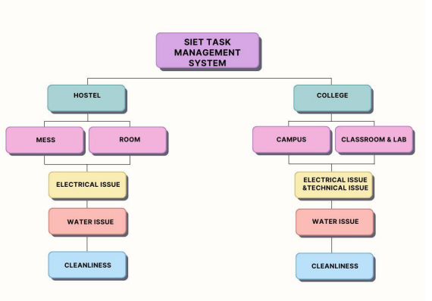

This flowchart outlines the process of receiving, prioritizing, assigning,
and completing tasks within a task management system. It starts with
receiving a task request and proceeds through decision points to
determine task urgency, priority, assignment, and completion. It also
includes branches for handling urgent tasks, high-priority tasks, and
tasks requiring additional work

CHAPTER 5
SOFTWARE DESCRIPTION
5.1 HTML
HTML, or Hypertext Markup Language, is the standard markup language used to create and design documents on the World Wide Web. It structures the content of a web page by using a system of tags and attributes, allowing browsers to interpret and display the content appropriately. HTML is a foundational technology for web development, providing the basic structure that is enhanced and styled by CSS (Cascading Style Sheets) and made interactive by JavaScript.

5.2 CSS (CASCADING STYLE SHEETS)
CSS is a style sheet language used to control the presentation and layout of HTML or XMLdocuments on the web. It allows developers to define styles for elements, specifying aspects such as colors, fonts, spacing, and positioning. CSS uses selectors to target specific elements and declarations to set their styling properties. Key concepts include the box model, which defines how elements are visually represented, and responsive design principles to adapt layouts to different screen sizes.

5.3 JS (JAVA SCRIPT)
JavaScript, often abbreviated as JS, was created by Brendan Eich in 1995 while he was working at Netscape Communications. Originally developed as a lightweight scripting language to add interactivity to web pages, it has since evolved into a powerful programming language widely used for both front-end and back-end development.

Here are some key features and concepts of JavaScript:
1. *Syntax*: JavaScript syntax is similar to that of C programming language. It uses curly braces for blocks of code and semicolons to terminate statements.

2. *Dynamic Typing*: JavaScript is dynamically typed, meaning you don't have to declare the data type of a variable explicitly. Variables can hold values of any data type.

3. *Functions as First-Class Citizens*: Functions in JavaScript are treated as first-class citizens, which means they can be assigned to variables, passed as arguments to other functions, and returned from other functions.

4. *Event-Driven Programming*: JavaScript is often used for event-driven programming, where actions on a web page (like button clicks or mouse movements) trigger JavaScript code to execute 14.

5. *DOM Manipulation*: JavaScript is commonly used to manipulate the Document Object Model (DOM) of a web page, allowing developers to dynamically change the content, structure, and style of a page in response to user actions.

6. *Asynchronous Programming*: JavaScript supports asynchronous programming through mechanisms like callbacks, promises, and async/await. This allows non-blocking code execution, essential for handling tasks such as fetching data from servers without freezing the user interface.
7. *Object-Oriented Programming (OOP)*: Although JavaScript is not a purely object-oriented language, it supports object-oriented programming concepts such as objects, classes (introduced in ES6), inheritance, encapsulation, and polymorphism.

8. *Frameworks and Libraries*: JavaScript has a vast ecosystem of frameworks and libraries that simplify and streamline development tasks. Some popular front-end frameworks include React.js, Angular, and Vue.js, while Node.js is a popular back-end framework.

CHAPTER 6
SOURCE CODE

6.1 HTML CODE
FRONT PAGE:
<!DOCTYPE html>
<html>

<head>
<style>
body {
margin: 0 0 0 0px;
}

.scroll {
width: 100%;
height: 50px;
background: rgb(80, 237, 80);
margin-top: 0%;
}

.top {
margin-left: 0px;
margin-right: 0px;
display: flex;
}

.logo {
width: 50px;
height: 50px;
background-image: url('logo1.png');
background-repeat: no-repeat;
background-size: contain;
}

.dropdown {
height: 100px;
width: 912px;
}

.quotes {
padding-top: 0%;
}

ul li,
a {
display: inline;
text-decoration: none;
font-size: x-large;
color: rgb(0, 162, 0);
padding-right: 10px;
padding-top: 5px;
}

li a:hover {
color: #e8ef1b;
text-decoration: overline;
}

ul {
margin-top: 30px;
margin-left: 390px;
}

.line {
width: 1540px;
height: 1px;
background-color: rgb(0, 162, 0);
margin-top: 0px;
}

h1 {
color: #e8ef1b;
margin-top: 5px;
}

p {
font-size: x-large;
margin-left: 60px;
margin-top: 50px;
color: green;
}

h2 {
margin-left: 40px;
margin-top: 70px;
color: rgb(191, 185, 32);
text-decoration: underline;
}

drop-list {
width: 100px;
height: 100px;
background-color: white;
}

.dropdown {
position: relative;
display: inline-block;
}

.image {
width: 50px;
height: 200px;
}

#mention {
font-family: 'Times New Roman', Times, serif;
font-weight: 50px;
color: green;
padding-top: 100px;
margin-left: 100px;
}

#college {
margin-left: 100px;
font-size: large;
background-color: green;
font-family: 'Times New Roman', Times, serif;
border-radius: 8px;
height: 50px;
font-weight: 100px;
color: white;
}

#hostel {
margin-left: 100px;
font-size: large;
background-color: green;
font-family: 'Times New Roman', Times, serif;
border-radius: 8px;
height: 50px;
font-weight: 100px;
color: rgb(255, 255, 255);
}

.slider {
width: 1300px;
max-width: 100vw;
height: 700px;
margin: auto;
position: relative;
overflow: hidden;
}

.slider .list {
position: absolute;
width: max-content;
height: 100%;
left: 0;
top: 0;
display: flex;
transition: 1s;
}

.slider .list img {
width: 1300px;
height: 90%;
object-fit: cover;
}

.slider .buttons {
position: absolute;
top: 45%;
left: 5%;
width: 90%;
display: flex;
justify-content: space-between;
}

.slider .buttons button {
width: 50px;
height: 50px;
border-radius: 50%;
background-color: #fff5;
color: #fff;
border: none;
font-family: monospace;
font-weight: bold;
}

.slider .dots {
position: absolute;
bottom: 10px;
left: 0;
color: #fff;
width: 100%;
margin: 0;
padding: 0;
display: flex;
justify-content: center;
}

.slider .dots li {
list-style: none;
width: 10px;
height: 10px;
background-color: #fff;
margin: 10px;
border-radius: 20px;
transition: 0.5s;
}

.slider .dots li.active {
width: 30px;
}

@media screen and (max-width: 768px) {
.slider {
height: 400px;
}
}
</style>
<link href='https://unpkg.com/boxicons@2.1.4/css/boxicons.min.css' rel='stylesheet'>

</head>

<body>
<div class="container">
<div class="scroll">
<h1 style="text-align: center;">TASK MANAGEMENT SYSTEM</h1>
</div>
<div class="top">
<div class="logo"></div>
<div class="dropdown">
<ul>
<li><a href="#"><img src="https://encrypted-tbn0.gstatic.com/images?q=tbn:ANd9GcTeASUvdF909L11DcwxeG-GkBILLwPtBo-PtQ&s" alt="Logo" style="width:30px; height:30px; vertical-align:left; margin-right:5px;"> Home</a></li>
<li><a href="#">Problems</a></li>
<li><a href="#">Contact</a></li>
<li><a href="#">Login</a></li>
</ul>
</div>
</div>
<div class="line"></div>
<div><br><br><br></div>
<div class="slider">
<div class="list">
<div class="item">
<img src="https://allegiance-educare.in/storage/uploads/colleges/1472024414a6.png" alt="">
</div>
<div class="item">
<img src="https://allegiance-educare.in/storage/uploads/colleges/1472024414a6.png" alt="">
</div>
<div class="item">
<img src="https://allegiance-educare.in/storage/uploads/colleges/1472024414a6.png" alt="">
</div>
<div class="item">
<img src="https://allegiance-educare.in/storage/uploads/colleges/1472024414a6.png" alt="">
</div>
</div>
<div class="buttons">
<button id="prev"></button>
<button id="next">></button>
</div>
<ul class="dots">
<li class="active"></li>
<li></li>
<li></li>
<li></li>
<li></li>
</ul>
</div>
<div class="quotes">
<h2>
ABOUT
</h2>
<p class="lead">Welcome to our college task management hub! Here, we understand that navigating the challenges of college life can be
daunting,<br><br>which is why we're here to help.Whether you're struggling with academic problems,hostel problems or simply
looking for resources <br><br>to enhance your college experience,you've come to the right place. Our dedicated team of experts
is committed to providing tailored<br><br> solutions to address your concerns effectively. Explore our website to discover how
we can assist you in overcoming obstacles.<br><br> Your success is our priority.</p>
</div>
</div>
<script src="slider_dots-main/app.js"></script>
</body>

</html>

LOGIN PAGE:
<!DOCTYPE html>
<html>
<head>
<meta charset="UTF-8">
<meta name="viewport" content="width=device-width, initial-scale=1.0">
<title>ADMIN LOGIN</title>
<style>
.login {
border: 1px solid black;
width: 90%;
max-width: 400px;
height: 500px;
background: fixed;
background-image: "add image";
background-position-x: center;
border-radius: 20px;
box-shadow: 0px 0px 20px rgba(0,0,0,0.75);
background-size: cover;
background-position: center;
overflow: hidden;
margin: auto;
}
form {
display: block;
box-sizing: border-box;
padding: 40px;
background-position-x: center;
align-content: center;
width: 100%;
height: 100%;
19
backdrop
-filter: brightness(40%);
flex
-direction: column;
display: flex;
gap: 5px;

}
h1 {
font
-weight: normal;
font
-size: 24px;
text
-shadow: 0px 0px 2px rgba(0, 0, 0, 0.5);
margin
-bottom: 60px;

}
Label{
color: rgba(0, 0, 0, 0.8);
text
-transform: uppercase;
font
-size: 10px;
letter
-spacing: 2px;
padding
-left: 10px;

}
input {
background: rgb(255, 255, 255);
height: 40px;
line
-height: 40px;
border
-radius: 20px;
padding: 0px 20px;
border: none;
margin
-bottom: 20px;
color: rgb(0, 0, 0);

}
.forgot
-password {
color: rgba(0, 0, 0, 0.8);
font
-size: 10px;
text
-transform: uppercase;
text
-align: right;
margin
-bottom: 20px;
text
-decoration: none;

}
.forgot
-password:hover {
text
-decoration: underline;

}
button {
background: rgb(45,126,231);
height: 40px;
line
-height: 40px;

border
-radius: 40px;
border: none;
margin: 10px 0px;
box
-shadow: 0px 0px 5px rgba(0,0,0,0.3);
color: white;
font
-size: 12px;
text
-transform: uppercase;

}
</style>
</head>
<body>
<div class="login">
<form>
<h1>ADMIN LOGIN</h1>
<label for="admin-id">Admin ID</label>
<input type="text" id="admin-id" name="admin-id" placeholder="Enter Admin
ID" autocomplete="off">
<label for="password">Password</label>
<input type="password" id="password" name="password" placeholder="Enter
Password" autocomplete="off">
<a href="#" class="forgot-password">Forgot Password?</a>
<button type="submit">SIGN IN</button>
</form>
</div>
</body>
</html>
MAIN PAGE:
<!DOCTYPE html>
<html lang="en">
<head>
<meta charset="UTF-8">
<meta name="viewport" content="width=device-width, initial-scale=1.0">
<title>Image Gallery with Load More</title>
<style>
body {
font-family: Arial, sans-serif;
background-color: #f4f4f9;
background-color: #85FFBD;
background-image: linear-gradient(45deg, #85FFBD 0%, #FFFB7D 100%);

margin: 0;
padding: 20px;
}
.container {
max-width: 1200px;
margin: 0 auto;
}
.row {
display: flex;
flex-wrap: wrap;
}
.image {
display: none; /* Initially hide all images */
padding: 10px;
}
.imag {
margin-bottom: 20px;
border: 1px solid #ff0000;
padding: 10px;
border-radius: 4px;
background-color: #fff;
box-shadow: 0 0 10px rgba(0, 0, 0, 0.1);
}
.imag img {
width: 100%;
height: auto;
border-radius: 4px;
}
.text {
text-align: center;
margin-top: 10px;
}
.load-more {
margin-top: 20px;
}
.col{
float:left;
font-size: larger;
padding: 15px;
}
.pic{
max-width:200px;
background-color: #f4f4f9;

}
</style>
<!-- jQuery -->
<script
src="https://ajax.googleapis.com/ajax/libs/jquery/3.5.1/jquery.min.js"></script>
<!-- Bootstrap JS -->
<script
src="https://stackpath.bootstrapcdn.com/bootstrap/4.5.2/js/bootstrap.min.js"></script>
<script>
$(document).ready(function () {
$(".image").slice(0, 4).show(); // Show the first 4 images
$(".load-more").click(function (e) {
e.preventDefault();
$(".image:hidden").slice(0, 4).slideDown(); // Show 4 more images
if ($(".image:hidden").length == 0) {
$(".load-more").fadeOut('slow'); // Hide the button when all images are
shown
}
});
});
</script>
</head>
<body>
<div class="container">
<div class="row">
<div class="col col-lg-12">
<h2>COLLEGE ISSUES</h2>
</div>
</div>
<div class="row">
<div class="col-md-12 text-center">
<h1>Image Gallery</h1>
</div>
</div>
<div class="row">
<div class="col-md-3 image">
<div class="imag">
<a href="doc.html"><img src="water-tap.png" alt="Image 3"class="pic"></a>
<div class="text">
<p>WASHROOM WATER</p>
</div>
</div>
</div>
<div class="col-md-3 image">
<div class="imag">
<a href="doc.html"><img src="drink-water.png" class="pic" alt="Image
1"></a>
<div class="text">
<p>DRINKING WATER</p>
</div>
</div>
</div>
<div class="col-md-3 image">
<div class="imag">
<a href="doc.html"><img src=" electrical-energy.png " class="pic"
alt="Image 2"></a>
<div class="text">
<p>ELECTRICAL ISSUES</p>
</div>
</div>
</div>
<div class="col-md-3 image"><div class="imag">
<a href="doc.html"><img src="light.png" class="pic" alt=""></a>
<div class="text">
<p>LIGHT ISSUES</p>
</div>
</div>
</div>
<div class="col-md-3 image">
<div class="imag">
<a href="doc.html"><img src="projector.png" class="pic"></a>
<div class="text">
<p>PROJECTOR ISSUES</p>
</div>
</div>
</div>
<div class="col-md-3 image">
<div class="imag">
<a href="doc.html"><img src="ceiling.png" class="pic" alt="Image
6"></a>
<div class="text">
<p>FAN ISSUES</p>
</div>
</div>
</div>
<div class="col-md-3 image">
<div class="imag">
<a href="doc.html"><img src="cleaner.png" class="pic" alt="Image
7"></a>
<div class="text">
<p>SANITARY ISSUE</p>
</div>
18
</div>
</div>
<div class="col-md-3 image">
<div class="imag">
<a href="doc.html"><img src="teacher.png" class="pic" alt="Image
8"></a>
<div class="text">
<p>FACULTY ISSUES</p>
</div> </div> </div> <div class="row mt-3">
<br>
<div class="col-xl-12 text-center">
<br><br><br><br><br><br><br><br><br><br><br><br><br>
<button class="load-more btn btn-primary">Load More</button>
</div>
</div>
</div>
</body>
</html>

CHAPTER 7
RESULT AND ANALYSIS
7.1 FRONT PAGE
The front page of a web page, commonly referred to as the homepage, is the initial or main page that users see when they visit a website. It serves as the entry point to the site and typically provides an overview of the website's content, navigation options, and key features. The front page often includes elements such as a site logo, navigation menu, featured content or promotions, and links to other sections of the website. Its design and layout are crucial for creating a positive first impression and guiding users to explore further.
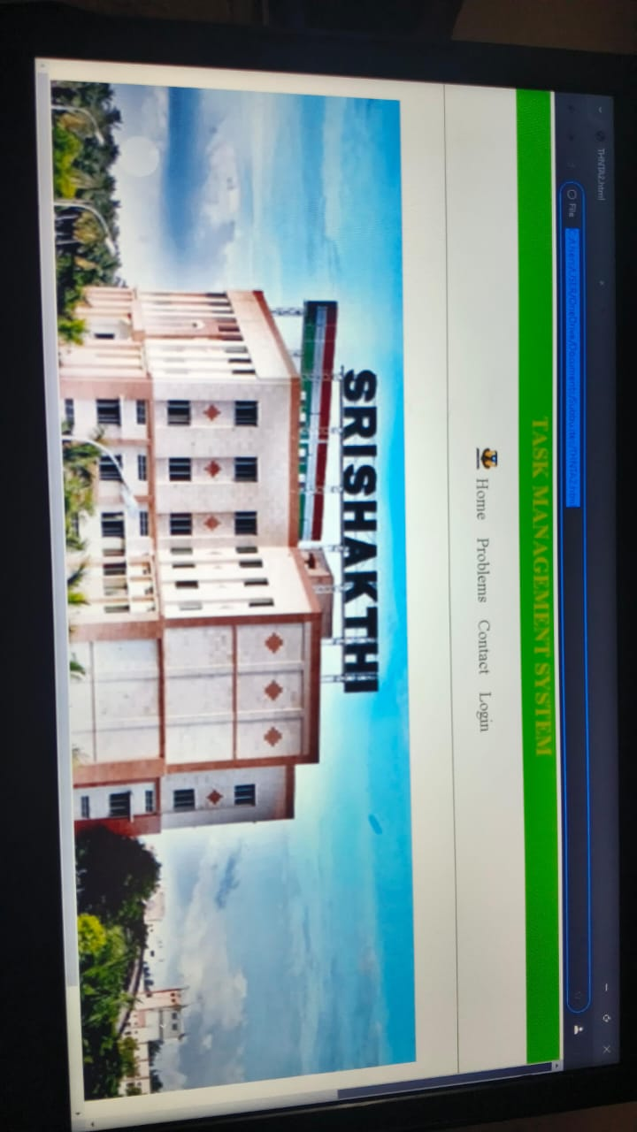


7.2 LOGIN PAGE
The login page serves as the primary gateway for users to access secure content or perform actions within a web application. Its design should prioritize both usability and security, providing a seamless yet fortified authentication process. To achieve this balance, several crucial aspects need consideration.

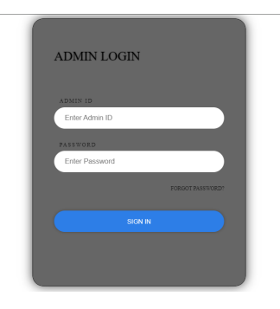

7.3 USER PAGE
User pages within web applications play a pivotal role in shaping user experiences and facilitating interaction between users and digital platforms. This abstract delineates key principles and strategies for designing compelling and user-centric user pages, fostering engagement and usability.
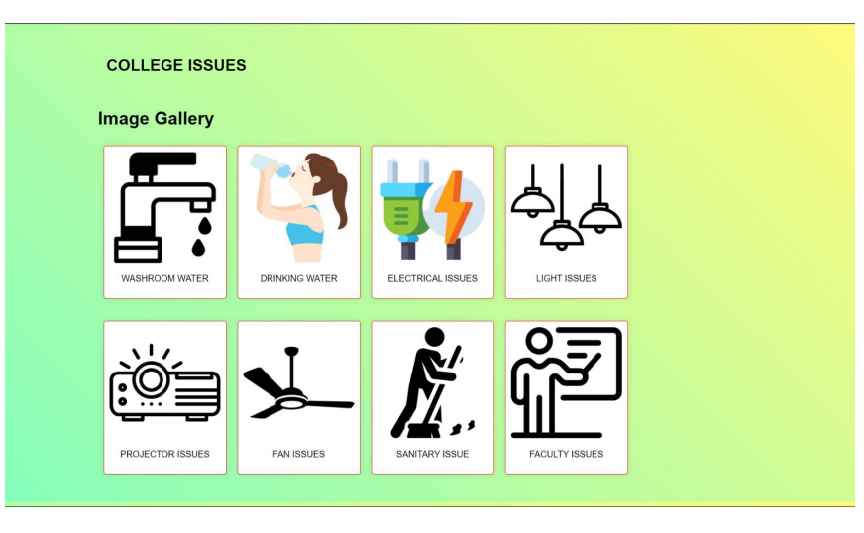

CHAPTER 8
CONCLUSION AND FUTURE SCOPE

8.1 CONCLUSION

In conclusion, the development of the CLG Task Management System represents a significant step towards enhancing organizational efficiency and productivity. Through its user-friendly interface, robust features, and seamless integration capabilities, the system streamlines task allocation, tracking, and collaboration processes. With further refinement and user feedback incorporation, the CLG Task Management System is poised to become an indispensable tool for optimizing workflow management and achieving project success.

8.2 FUTURE SCOPE

Looking ahead, the future scope for the CLG Task Management System includes several exciting avenues for expansion and improvement. Firstly, incorporating advanced analytics and reporting functionalities can provide deeper insights into task performance and team productivity. Additionally, integrating artificial intelligence algorithms can automate task prioritization and allocation, further streamlining workflow processes. Furthermore, extending compatibility to mobile platforms can enhance accessibility and flexibility for users on the go. Lastly, continuous user feedback and iterative updates will be crucial in ensuring that the system remains relevant and effective in meeting evolving organizational needs.

8.2.1 ENHANCED REPORTING AND ANALYTICS
Implement advanced reporting tools and analytics features to provide insights into common issues and user behavior. This can assist College in making informed decisions.

8.2.2 INTEGRATION WITH E-COMMERCE PLATFORMS
Explore the integration of the task management system with e-commerce platforms to facilitate online work . This could involve incorporating online reporting, issue clearance and management functionalities.

8.2.3 MOBILE APPLICATION DEVELOPMENT
Develop a mobile application to extend the reach of the task management system. A mobile app can provide users with convenient access to promotions, loyalty programs, and real-time information about
Management.

8.2.4 INTELLIGENT INVENTORY MANAGEMENT
Implement machine learning algorithms to predict demand, optimize inventory levels, and minimize stockouts. This can enhance efficiency in inventory management and reduce carrying works.

8.2.7 ENHANCED SECURITY FEATURES
Continuously enhance security measures to protect sensitive data. This may involve implementing multi-factor authentication, encryption, and regular security audits.

CHAPTER 9
REFERENCES

2.1 Kasmawahida Ab Wahab, School of Computing & Analytics, Faculty of Science ,Engineering & Agrotechnology, University College of Yayasan Pahang, Taman Gelora Campus, 25050 Kuantan, Pahang, Malaysia
2.2 Online Task Management System (OTMS), GRISHMA HEDAOO1, PRIYANKA THOKE2, RAKSHA TABHANE3, SHUBHAM MESHRAM4 ,SWAPNILKUMBHALKAR5, PROF. MUKESH BARAPATRE , S. B. Jain Institute of Technology, Management and Research, Nagpur, India
2.3 Author={Bellotti, Victoria and Dalal, Brinda and Good, Nathaniel and Flynn, Peter and Bobrow, Daniel and Ducheneaut , Nicolas},year = {2004},month = {04},pages = {735-742},title = {What a to-do: studies of task management towards the design of a personal task list manager},volume={24–29},journal = {Proceedings of CHI, Vienna, Austria}

